Install"Cura_15.04.3.exe"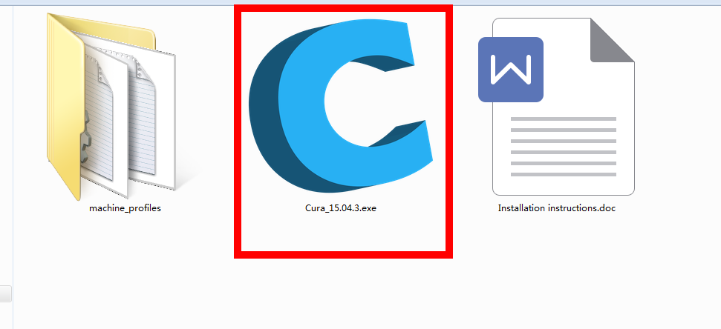After the installation is successful exit Cura.

Find the "disk:\Program Files (x86)\Cura_15.04.3\resources"
delete "machine_profiles" folder.
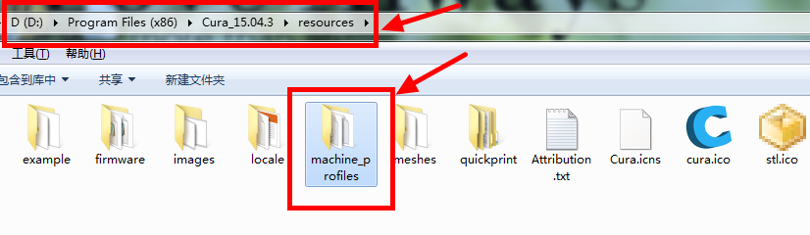

Copy the tutorial provided "machine_profiles" folder to:"disk \ Program Files (x86) \ Cura_15.04.3 \ resources" directory under .
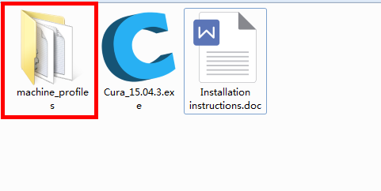
Start Cura. Select the "Machine" menu under "Add new machine"
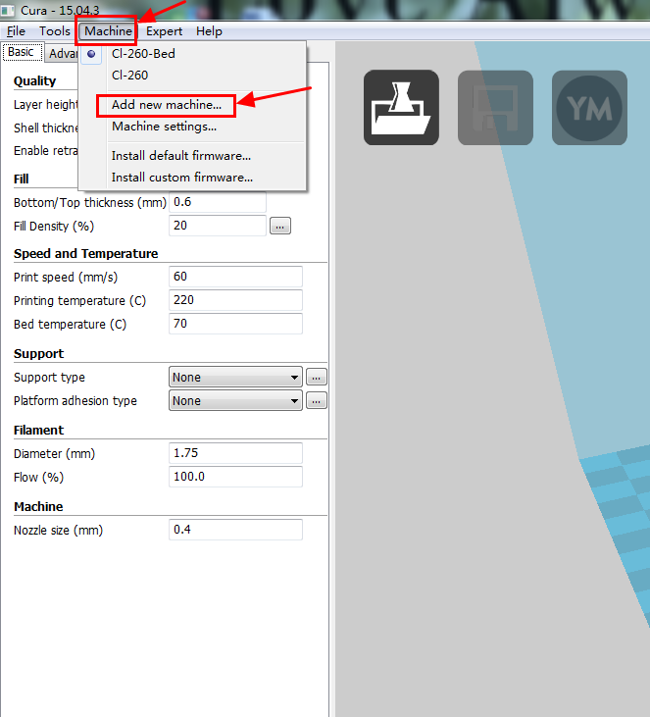

Click "Next".
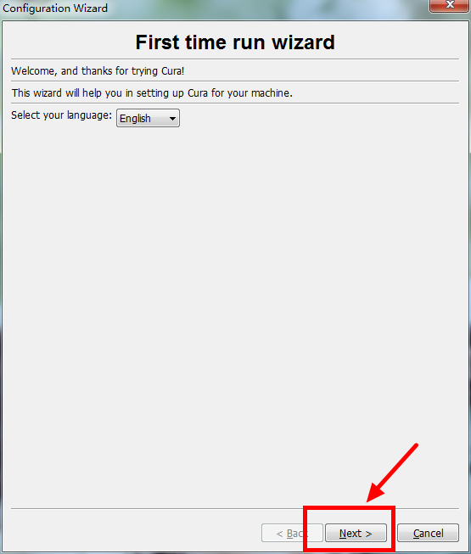

Choose "Other"
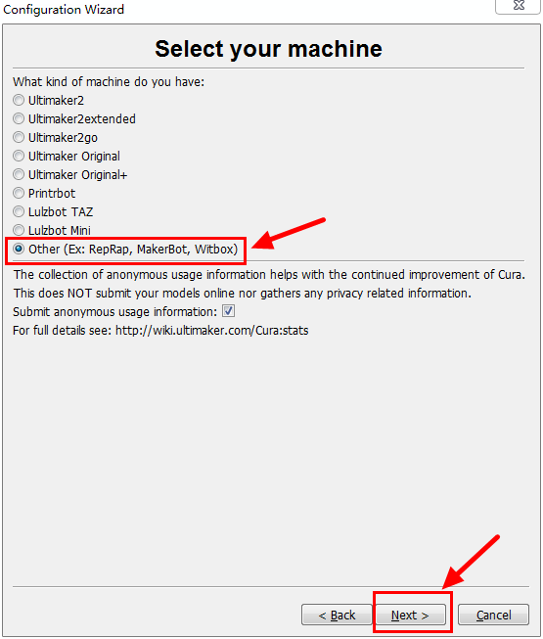

If your machine has a hot bed choice "CL-260A" no hot bed choice "CL-260"
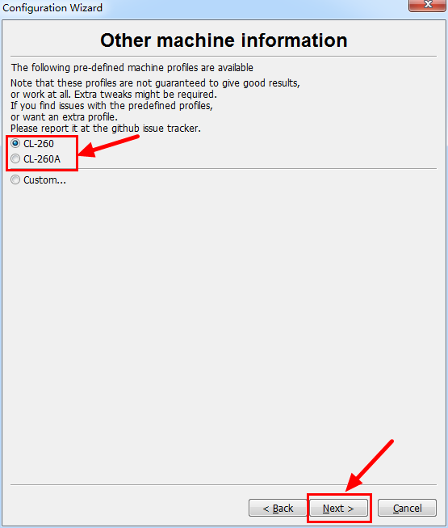

Click "Finish"
